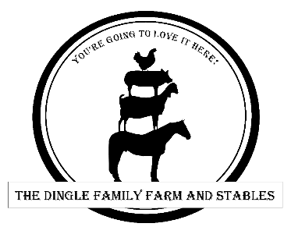
3630 Brown Road Oakley Ca 94561
Volunteer Form
We love our Volunteers they play an important role in our daily farm and facility operations. Please see our Volunteer needs listed below and let us know where you would like to help out.
Opportunities
Please let us know what volunteer program you are interested in:
___ Creatures Comfort, feeding barnyard animals once a week on weekday morning or evenings.
Commitment: 1 hour between the hours of 8:00A & 8:45A and 5:00P & 6:45P (To be confirmed)
___ Farm Beauty, cleaning, raking, weeding and maintaining the farm property.
Commitment: 1-hour weekly times very (to be confirmed)
Questions
Please answer the following questions:
- How did you learn about The Dingle Family Farm and Stables? _____________________________________________________________
- Do you need community service hours [] yes or [] No? If yes please explain? _____________________________________________________________
- What skills can you bring to this volunteer program? _____________________________________________________________

Contact information
Volunteer First & last name:

(if volunteer is a minor)
Parent or legal guardian First & Last Name:

_____________________________________________________________

Address:

Volunteer Phone Number: ____________________________________________ Text ok? Yes [] No []
(if volunteer is a minor)
Parent or Guardian Phone Number: _____________________Text ok? Yes [] No []
Email address: ___________________________________________________________________
Program Benefits
Benefits of volunteering with this program include:
- Experience working in environmental education
- Work with animals
- Get a behind the scenes look of the daily operations of the farm
- Work experience
- Eligible for written letters of recommendation and official volunteer hours for external program requirements

Qualifications
This opportunity is best suited for ages 15- adult. Volunteers should be comfortable around farm animals and in the outdoors. Volunteers must also be in good health and physical condition.
Volunteers under 18 must be accompanied by an adult. Adults may wait in the covered party area.
Character reference letters may be requested.

All Volunteer opportunities are by appointment only on an as needed basis.
Please tell us why you would like to Volunteer_

___________________________________________________________________________________

Please complete and send back to christina@thedinglefamilyfarmandstables.com

